Student Project Safety Summary

Student Name:
Summary Date:
Mentor(s):
Project Title:

Project Overview:

Chemicals Expected to be Used:
OSHA is using the Globally Harmonized System (GHS) for classifying and categorizing chemicals. Under the GHS system, chemicals are classified according to physical, health and environmental hazards. Each hazard of a chemical or mixture is assigned a category with a numerical rating. In the table below, please list all chemicals you are expecting to use in your research project. Look up the Safety Data Sheet for each chemical and indicate in the table the hazard category number or letter assigned to each hazard of the chemical. Add more rows as necessary. As an example, the hazards for dimethylmercury are shown in the first row.
Table 1: Hazardous Chemical List
Hazard: Please indicate the GHS Category
Refer to Table 3 below for the hazards associated with each of these pictograms
Hazardous  Chemical/  Signal Word | 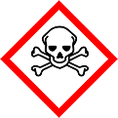 | 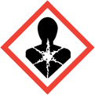 | 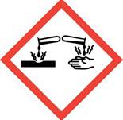 | 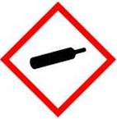 | 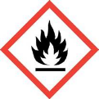 | 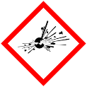 | 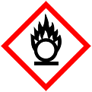 | 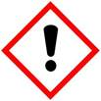 | Serious Eye Damage | Other  (Please detail)
Dimethylmercury  Danger | Oral- 2  Inhalation-2  Dermal- 1 | Carcinogen-2  Organ-2 |  |  | 2

Lab Operations/Equipment
In addition to the chemical hazards present in laboratories, many procedures and equipment pose hazards as well. In the table below, please list any experimental procedures and/or equipment (centrifuge, sharps, x-ray diffractometer, etc.) that you will use in your research that require additional training beyond what you receive in the department general safety training.
Table 2: Hazardous Procedures and Equipment
Hazardous  Procedure/Equipment | Potential Hazard | Control Measures and Precautions

What personal protective equipment will you use?

Do any of the chemicals or lab operations above require additional or specialized personal protective equipment?

Are there any activities that you can only perform with your research mentor present?

Are there any activities that require you to work outside of normal working hours?

Table 3: GHS Pictorgrams and Hazards
